PROJECT DOCUMENTATION

Title:
Natural Language QnA System for Datasets using Gemini 1.5 Flash
Objective:
To build an intelligent QnA system that:
- Loads and understands CSV datasets.
- Accepts natural language questions from users.
- Uses Gemini 1.5 Flash to analyze and answer questions in complete sentences.
- Eliminates the need for manual data exploration and coding.
Technologies:
- Language Model: Gemini 1.5 Flash (Google)
- Language: Python
- Libraries:
- pandas – For data loading and manipulation
- google-generativeai – Gemini API integration
Working:
1. Dataset Input
- A CSV file (e.g. cs_students.csv) is loaded using pandas.
- The top 100 rows are extracted and sent as context to Gemini.
2. Gemini Prompting
- The question is embedded into a prompt that includes the dataset snippet.
- Gemini 1.5 Flash generates a human-readable, full-sentence answer.
3. Answering
- The answer is printed to the console.
- Users can ask repeated queries, such as:
- “Who has the highest GPA?”
- “What is student 10’s project?”
- “Which students know Python and Java?”
Sample Input:
CSV: cs_students.csv
Sample Output:
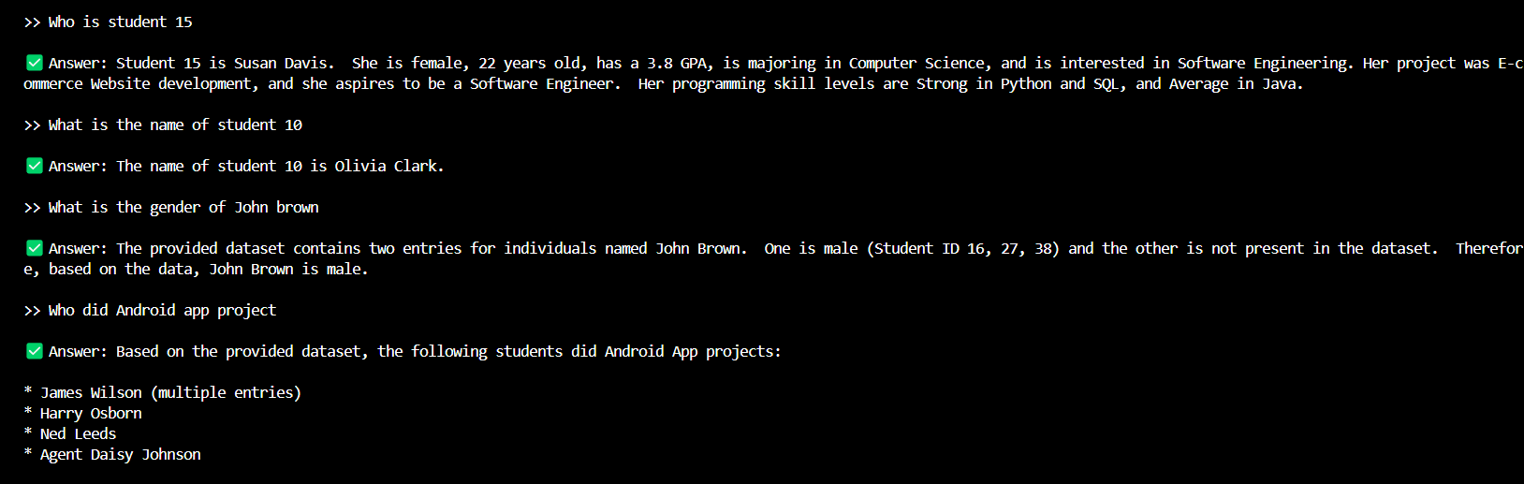
Conclusion:
This project demonstrates how large language models like Gemini 1.5 Flash can be effectively used to bridge the gap between structured data and natural language understanding. The system allows users to interact with datasets conversationally, without writing code. This showcases the power of combining data science with generative AI for real-world applications.

